Name:

3.6 Reproduction and Growth – Plant | Objectives
3.6.1 Sexual Reproduction - Plants | - State the structure & function of the floral parts including: Sepal, Petal, Stamen, Carpel  - State that the Pollen grain produces male gamete.  - State that the Embryo sac produces an egg cell & polar nuclei.  - Define the terms: pollination, self-pollination  - Outline methods of pollination including: cross-pollination & self pollination  - Define the term: fertilisation.  - Outline seed structure & function of following: testa, plumule , radicle, embryo, cotyledon  - Explain embryo & food supply (endosperm or seed leaves)  - Classify plants as monocotyledon or dicotyledon & distinguish between them.  - Make reference to non-endospermic seed.  - Outline fruit formation.  - Outline seedless fruit production.  - Outline fruit & seed dispersal and give with examples of wind/water/animal/self dispersal  - Explain & emphasise the need for dispersal  - Define the term dormancy.  - State advantages of dormancy.  - Explain dormancy in agricultural & horticultural practice.  - Define the term: Germination.  - Explain the factors necessary for and role of digestion and respiration in germination.  - Outline the stages of seed development  Vegetative Propagation  - State that vegetative propagation is asexual reproduction.  - Give one example of vegetative propagation from stem, root, leaf, bud.  - Compare reproduction by seed and by vegetative reproduction.  - Outline four methods of artificial propagation in flowering plants
3.6.3.H Plants (extended) | - Outline pollen grain development from microspore mother cells  - Explain meiotic division of these cells  - Explain mitotic division of these cells  - Discuss generative and tube nuclei formation  - Discuss formation of pollen grains  - Outline embryonic sac development  - Discuss meiotic division, cell disintegration  - Outline the formation of the egg cell by mitotic division
Practical Activity:

ME - To investigate the effects of water, oxygen and temperature on Germination
ME - To investigate the use of Starch agar to show Digestive Activity during Germination

The Flower

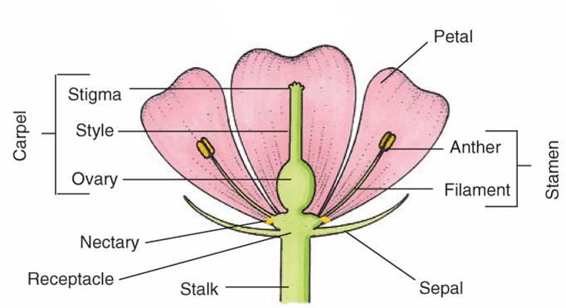

Flower parts:
*Sepals - protect flower when it is a bud (usually green).

*Petals - large, brightly coloured and scented to attract insects in animal-pollinated plants. Small, green or absent in wind-pollinated plants.

*Stamen (male) composed of anther and filament. Anther produces pollen grains and filament supports anther and supplies it with food and water.

*Carpel (female)- composed of stigma, style and ovary.
*Stigma is where pollen land.
*Style is where the pollen tube grows towards the ovary.
*Receptacle - swelling on which flower is supported.

Nectary - produces sugary substance called nectar. Attracts insects for pollination.

*Sexual reproduction involves the fusion of gametes from both parents.

*Gametes are haploid sex cells.

Sexual reproduction involves the fusion of gametes from both parents.
- Pollination: the transfer of pollen from anther to stigma.
- Fertilisation: fusion of male and female gametes to form a zygote.
- Dispersal: the spreading out of the seeds.
- Germination: the growth of the plant embryo after the dormant period.
.
Development of pollen
Pollen grain produces male gametes.
T.S. of anther

1. Inside each pollen sac are a number of diploid pollen mother cells which divide by meiosis to form four haploid pollen grains which stick together (tetrad).
2. The pollen grains (microspores - called spores because unable to fertilise a female gamete) separate. Each pollen grain has a double wall (*exine on the outside, intine).
3. The pollen grain nucleus divides by mitosis to form two haploid nuclei (tube nucleus and generative nucleus).
4. As the pollen grains mature, the tapetum (nourishment) is used up, the pollen sacs fuse and lines of dehiscence (splitting) appear, the sacs burst and the pollen grains are removed by insects or wind.

Development of embryo sac
Embryo sac produces an egg cell and polar nuclei.

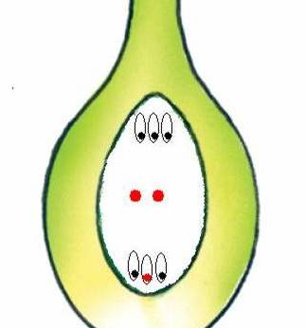

Each ovule consists of a nutritious tissue called nucellus. Inside which lives the embryo sac mother cell.
The diploid embryo sac mother cell divides by meiosis to form four haploid cells, three of which die. The single haploid nucleus within the embryo sac (megaspore) undergoes mitosis 3 times (i.e. 8 haploid nuclei). One forms the egg cell and two form the polar nuclei (all three = female gametes).

*Pollination is the transfer of pollen from an anther to a stigma of a flower of the same species.
*Cross -pollination is the transfer of pollen from the anther of one plant to the stigma of another plant of the same species.
*Self-pollination occurs when pollen is transferred from the anther to the stigma of the same flower or to another flower on the same plant e.g. cereals.
Cross pollination ensures seeds show more variation and vigour.
It may be brought about by wind or animals.

 | Animal pollinated | Wind pollinated
Flower | Large, brightly coloured petals, scented and nectar to attract and reward insects. | Small and petals green if present, no scent/nectar.
Pollen | Small amount of large, heavy, sticky, spiky pollen – to attach to insect’s body. | Large amounts, small, light, dry, round, smooth pollen – easily carried by wind, large nos. allows for wastage.
Stigmas | Small, round, sticky, inside flower – forces insect to forage. | Large, feathery, outside flower easier to catch pollen.
Anthers | Small, inside flower - forces insect to forage  e.g. wall flower, sweet pea, tulip, snowdrops. | Large, outside flower – for easy release of pollen  e.g. grass, oak, hazel, alder, conifers.

Hay fever
Hay fever is an allergic reaction to the inhalation of certain harmless substances e.g. pollen grains, fungus spores, animal skin or scales, house dust & house dust mites.
- Symptoms = inflammation of mucous membranes in nose, sneezing, blocked and runny nose, watery & irritated eyes.
- Treatments – avoid the allergen, decongestant drugs to clear nose, antihistamines to reduce inflammation.

Plant breeding techniques
Plants such as wheat, which grows quickly, are resistant to disease and pests, and produce a large amount of good quality pollen. Cross-pollination can be brought about artificially. The anthers are removed from one plant – to prevent self-pollination. When the carpels are ripe, pollen from the second plant is dusted on using a brush and plant is covered.
Can also be achieved by tissue culturing. A piece of tissue is taken from plant, grown in nutrient medium until a mass of cells forms. One cell is taken and grown in another medium and a new plant is formed.

*Fertilisation
This is the fusion of the male gamete with the female gamete to form a diploid zygote.
Events before fertilisation:
Once the pollen grain lands on the stigma it produces a pollen tube, which grows down the style to the ovule.
As the pollen tube grows down, the generative nucleus (n) divides by mitosis to form two sperm nuclei (male gametes) (n). The tube is guided by chemotropism and by the tube nucleus which dies when the tube enters the ovule by the micropyle.

Double fertilisation occurs:
One sperm nucleus fuses with the egg nucleus to produce a diploid zygote (2n).
The second sperm nucleus fuses with the two polar nuclei to form a triploid endosperm nucleus (3n)
The zygote develops into an embryo plant and the endosperm forms a food supply for embryo.

Seed/fruit formation
ovule becomes the seed.
integuments become the testa (seed coat)
ovary becomes the fruit (or a modified floral part e.g. apple & strawberry (from receptacle)
ovary wall becomes the pericarp (fruit wall)

Developing seeds produce growth regulators to stimulate growth of the fruit tissues.

Seed structure
Testa: tough hard seed coat. Protects seed before germination.
Hilum: Scar. Left by stalk which attached ovule to ovary wall.
Micropyle: pore
Embryo consist of the radicle, plumule and cotyledons:
Radicle: develops into the root.
Plumule: develops into the shoot.
Cotyledons: seed leaves – formed by some of the embryo cells. These contain food reserves which are used in the early stage of germination - before the young plant can make its own food. They secrete enzymes which digest endosperm food, absorb it and pass it on to the developing embryo.

Classification of seeds:
- Number of cotyledons
Monocot - 1 cotyledon (1 seed leaf) e.g. grass, cereals, daffodils
Dicot - 2 cotyledons (2 seed leaves) e.g. broad bean, pea, sunflower, peanuts.
- Endosperm: endospermic seeds have an endosperm e.g. maize; non– endospermic seeds have no endosperm e.g. broad bean.

The endosperm of wheat seeds is full of starch and this is what is used to make flour.

Broad bean Maize seed

Fruits
Functions:
To protect the seeds
To enable seeds to be dispersed.

Seedless fruit
Seedless fruit production (parthenocarpy) can be formed genetically, either naturally or by special breeding programmes e.g. bananas and cucumbers, seedless grapes/oranges.
Or by spraying flowers with growth regulators (auxin or gibberellin) - this causes fruit to form without fertilisation taking place e.g. seedless grapes, peppers, cherries, apricots, peaches & some tomatoes.
These growth regulators also cause fruit and vegetable to grow larger.
The plant growth regulator ethane is used to ripen or ‘degreen’ fruits e.g. melons, bananas, tomatoes. CO₂ inhibits production of ethene – hence apples can be stored over the winter.

*DISPERSAL
This is the carrying of fruit or seed as far away as possible from the parent plant to ensure survival and minimise the chance of overcrowding and competition.

(a) Wind dispersal:
- Small, light seeds e.g. orchids
- Winged fruits/seeds “helicopters” e.g. sycamore, ash
- Capsules e.g. poppy.
- Parachutes: Plumed fruits e.g. hairy tuft of dandelion, thistle or clematis acts as a parachute.

(b) Animal dispersal:
- Sticky, hooked fruit/seeds e.g. goosegrass, burdock, buttercup become attached to animal coat.
- Edible, fleshy or succulent fruits e.g. blackberry, acorns are eaten by animals, the seeds pass through digestive system and are deposited away from parent plant.

(c) Water dispersal
Floating fruits e.g. water-lily (spongy coat makes them buoyant), coconut (due to large air cavities), alder.

(d) Self-dispersal
Dehiscent fruits have an explosive mechanism e.g. peas, beans, gorse.

*DORMANCY:
A resting phase of reduced metabolic activity.

Causes of dormancy:
- Chemical growth inhibitors (e.g. abscisic acid) in testa (may be broken down by water, cold, decay).
- Testa may be impermeable to water and oxygen (eventually decays and allows water and oxygen in)
- Testa too hard for embryo to emerge.
- Embryo is slow to develop due to lack of growth regulator. Regulator may be produced due to increased light or temperatures in spring.

Dormancy in agriculture and horticulture
- Some seeds need a long cold period to bring on germination e.g. apple seeds. The cold may cause the breakdown of the growth inhibitors or the production of the growth promoters such as auxins.
- Other conditions needed before seeds planted include soaking seeds in water, physical damage (e.g. scraping them with fine sandpaper), exposing them to light or dark, exposing them to cold temperatures).

Advantages of dormancy.
- Allows seed to withstand cold winter and adverse conditions e.g. drought.
- Allows germination in spring e.g. warm, good weather.
- By having some seeds dormant in the soil (seed bank) plants can recover from harsh conditions in any particular year or fire etc.
- Allows time for dispersal by wind, water etc. and colonise new areas.
- Allows time for immature embryo to develop.

*GERMINATION:
Regrowth of embryo following dormancy.

Requirements:
- Moisture: for enzyme activity and for the formation of cell sap (it fills the vacuoles of the newly-formed cells to enlarge and give them turgor), to physically split the testa, to change insoluble food to soluble form (including hydrolysis of starch).
- Oxygen: for respiration of food in endosperm/cotyledon
- Warmth: effects enzyme action (5ºC - 40ºC).
(Light - most seeds are indifferent. Some need light e.g. lettuce, dandelion)

Digestion and use of food store in a seed
Enzyme | Food store digested | Product(s) formed | Use of products
 | oils | Fatty acids &glycerol | Respiration
 | starch | glucose | Respiration & structures (e.g. cell walls)
 | proteins | Amino acids | enzymes

Expts.: To show the effect of oxygen/water/ temperature on germination.

Types of seedling growth:
(a) cotyledon remains below ground e.g. broad bean. Seed absorbs water and begins to grow. Radicle grows down. Plumule emerges and the region between the cotyledon and the plumule grows pushing plumule upwards. The plumule produces the first true leaves which start to photosynthesise.

(b) cotyledons move above ground e.g. sunflower. Seed absorbs water, radicle grows down. The region between the radicle and the cotyledons grows causing the cotyledons to be carried above the soil. The cotyledons become green and photosynthesise. The plumule emerges from between the cotyledons and forms the first foliage leaves.

Expt.:To investigate digestive activity in seeds during germination using starch agar plates.

*Asexual reproduction is the production of organisms from one parent only (no seeds involved).
- Binary fission e.g. bacteria, amoeba
- Spores e.g. fungi.
- Budding e.g. yeast.
- *Vegetative reproduction is asexual reproduction in higher plants e.g. runners in strawberries.

A clone is a group of organisms which are formed by asexual reproduction (members have identical genotypes) e.g. potato, strawberry, amoeba, identical twins, ‘Dolly’ the sheep was cloned from the udder cells of another sheep.

Perennation is the ability of a plant to survive winter as an underground food store.
Advantages:
It allows rapid growth in spring before larger plants/trees get their foliage leaves and block out the sunlight.
The plant can flower and seed quickly - thus reducing competition with other plants.
The plant can survive cutting e.g. daffodils.

Organs of vegetative propagation
(learn one example of each)
Modified Buds (bulbs):
- A bulb is an underground swollen bud (stem is much reduced) that can overwinter beneath soil until the following year e.g. daffodil, onion, tulip, garlic. There is a small stem bearing a terminal bud and axillary buds enclosed in the bases of leaves swollen with food reserves. The axillary buds can grow, using some of the stored food and form foliage leaves and adventitious roots to form independent plants that become detached from the parent.
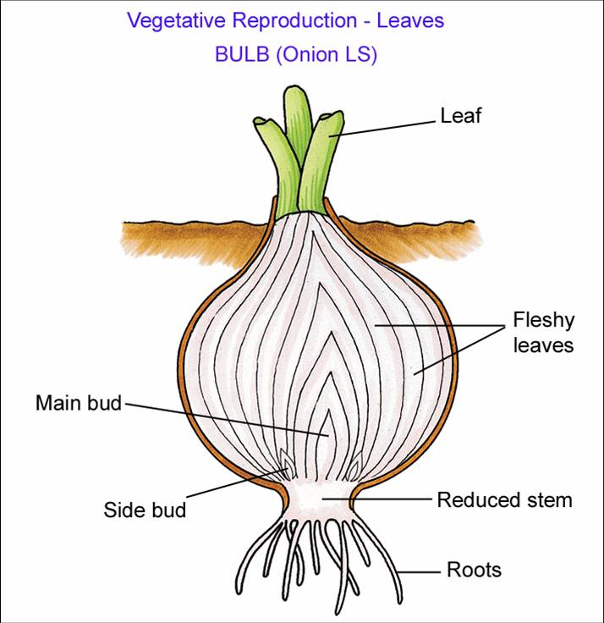
- Buds sometimes grow into new plants e.g. cacti.

Modified Leaves
- Some plants e.g. Bryopyllum/kalanchoe (mother of thousands) have leaves which give rise to plantlets along their length. These plants fall off and grow into new plants.
- In Begonia leaves fall from the plant and develop into new offspring.

Modified Stems:
Identified as stems because they bear buds or leaves or leaf scars.
Modified underground stems:
- Corms are short vertical underground stems, swollen with food reserves e.g. crocus, cyclamen and gladiolus.
Axillary buds develop between the stem and scale leaves surrounding the corm. Each may develop into a new plant. Each year the parent plant sends food down from the leaves to form a new corm on top of the old exhausted corm.

- Rhizomes are underground horizontal stems swollen with food reserves. It takes a few years to detach and form new plants e.g. primrose, mint, iris, couch grass. Axillary buds arise at scale leaves and grow side branches which grow adventitious roots and foliage leaves. They receive food from the parent and when the intervening rhizome dies, independent plants are established.

- Tubers e.g. potato, artichoke.
- 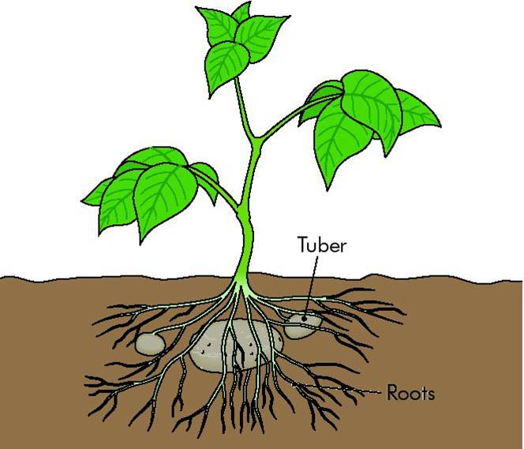
Tubers are swollen tips of underground stems. It has axillary buds (‘eyes’) that produce new shoots and roots using the stored food in the tuber. The parent tuber eventually dies away.

- Suckers: These are underground stems which run from parent and form new plant e.g. raspberry.

Modified overground stems:
- *Runners are stems that run along the ground and form new plants e.g. strawberry, creeping buttercup.
Runners develop from axillary buds at the base of the stem of the parent plant. The terminal bud of the runner sends up a daughter shoot and new roots form into the ground. They receive food from the parent. When the runner dies, independent plants are established.

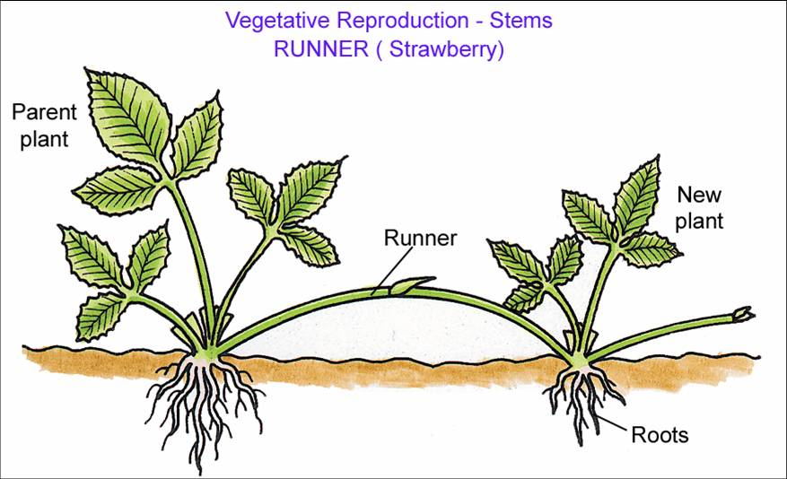

- Stolons e.g. blackberry, brambles.
These are aerial stems (branches) which bend over to touch the ground . They root and form new plants.

Modified Roots:
- Tubers e.g. dahlia, celandine.
*Root tubers are swollen fibrous roots which can grow into new plants.
An axillary bud lies at the top of each tuber just below the stem. Each bud can give rise to a new plant the following summer. Root tubers can be separated from parent plant.

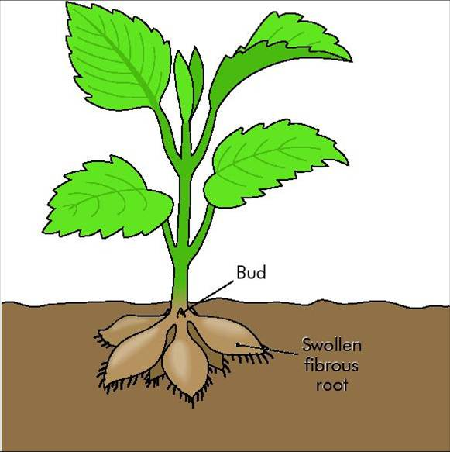

- Tap roots e.g. carrot
Tap roots are swollen main roots. They survive the winter and carry on growth in the spring.

Artificial methods of vegetative propagation

Learn 4 methods

- Cuttings: part of shoot is removed (cut an internode) and placed in soil or water to form roots e.g. buzy-lizzie, geranium (rooting powder may be used to promote rapid root development).
- *Layering: a cut shoot is pegged into soil and develops into a new plant.
After about one year adventitious roots grow and it is cut off from parent plant e.g. vines, carnation, blackberry.
- Budding: a bud (scion) is removed and taped into a cut on a root stock (e.g. wild rose) e.g. roses. Stock supplies food and support. Bud produces flowers and fruit. Often the stock has a good root system, but does not produce good flowers or fruit.
- Grafting: a shoot twig (scion) is removed and taped (and waxed to exclude microorganisms) into the root stock i.e. both cambium layers unite to form one plant e.g. apples, pears, roses.
- Micropropagation (tissue culture)
- Individual cells (small piece of stem, root or leaf) can be removed from a plant and then grown in tissue culture. Useful in the mass production of houseplants and commercial crops such as bananas, strawberries and oil palm trees.

Asexual v Sexual reproduction

Asexual reproduction | Sexual reproduction
Advantages:  1. Rapid growth due to maturity. | Disadvantages:  1. Plants may take years to develop.
2. Simple process (depends on mitosis) and reliable. | 2. Complex.
3. Not dependent on external agents for pollination, fertilisation and seed dispersal. | 3. Depends on external agents e.g. wind for pollination, seed dispersal etc. (Seeds are relatively large and makes dispersal difficult).
4. No waste. | 4. Wastage of fruit/seed by being eaten by animals, disease, overcrowding, parasites etc.
Rhizomes, bulbs and tubers can be separated to increase stock.
 | Seedlings are delicate.
Offspring identical (helps growers of e.g. fruit.
Disadvantages:  1. No variation. | Advantages:  1. Seeds show variation (helps evolution) e.g. getting disease resistant varieties.
2. Overcrowding and competition. | 2. Wide dispersal due to seeds and fruits. Hence no overcrowding and competition.
3. One disease can wipe out all as plants are similar. | 3. Some plants may be resistant to disease.
4. No seeds formed. | 4. Dormancy - allows survival in adverse conditions.

Plants can be classified as follows:
Annual plants are short-lived, after the seed germinates the plant grows, flowers and produces seeds within one growing season and then dies e.g. sweet pea, cereals, nasturtiums and marigolds.
Biennials do not reach maturity until the second year after the seed is sown e.g. cabbage, celery, turnip, carrot. (We do not usually see them reach maturity, and produce seeds in the second year because they are harvested during the first growing season).
Perennials live for a number of years and may be woody e.g. trees and shrubs, with continuously growing stems (within this classification woody plants may be deciduous or evergreen) or they may be herbaceous stems which die down at the end of each season and are replaced by new ones when growth is renewed e.g. daffodils. They survive by producing perennating organs e.g. bulbs.
Ephemerals: plants which produce several vegetations in the one year e.g. groundsel, shepherd’s purse, chickweed.

Sexual Reproduction

Higher Level
Section A

2005 HL
3. Indicate whether the following are true (T) or false (F) by drawing a circle around T or F.
(g) Light is essential for the germination of seeds. T F
(i) Parallel leaf veins are characteristic of monocotyledonous plants. T F
(j) Endosperm is a food reserve in some seeds. T F

2009 HL
2. The diagram shows a young plant growing in a tilted seed box.

(a) From which structure in the seed did A develop? __________________________________
2016 HL Q5

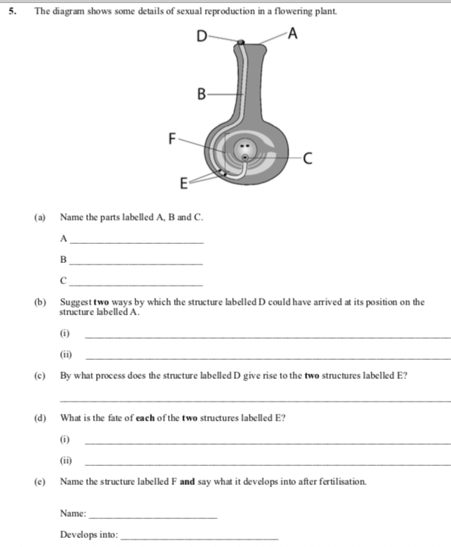
2017 HL Q6
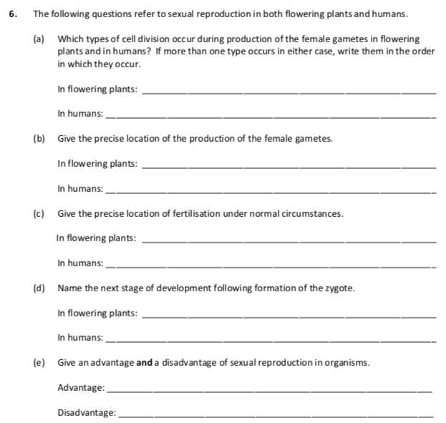
Section B
2006 HL
7. (b) In the case of each of the following state:
1. An investigation in which you used it,
2. The precise purpose for its use in the investigation that you have indicated.

(ii) Starch or skimmed milk agar plates.
1……………………………………………………………………………………………………
2……………………………………………………………………………………………………
…..…………………………………………………………………………………………………
……………………………………………………………………………………………….……
2009 HL
8. (a) (i) What is meant by germination? ______________________________________________
________________________________________________________________________
________________________________________________________________________
(ii) Why is digestion necessary in a germinating seed? _______________________________

(b) (i) Digestive activity during germination can be demonstrated by using agar plates.
What is an agar plate? _____________________________________________________
(ii) An extra food material is added to the agar plate for this demonstration.
Give an example of such an extra food material. _________________________________
(iii) Outline the procedures that you carried out in setting up this demonstration.
____________________________________________________________________
(iv) What control did you use for this demonstration?
____________________________________________________________________
(v) What procedure did you carry out in order to show that digestive activity had taken place?
____________________________________________________________________
(vi) Describe the results that you obtained in:
1. The experimental plate. ________________________________________________

2. The control plate. _____________________________________________________

2011 HL
8. (b) (i) In the course of your practical studies you used a solution of iodine in different
investigations. State two different uses of the iodine solution.
Use 1. ____________________________________________________________________
Use 2. ____________________________________________________________________
(ii) State two different uses of a water bath in biological investigations.
Use 1. ____________________________________________________________________
Use 2. ____________________________________________________________________
2012 HL
7. (iii) What type of agar plates did you use when investigating the digestive activity of seeds?
_________________________________________________________________________
(iv) How did you demonstrate that digestive activity had taken place in the investigation referred
to in part (iii)?
_________________________________________________________________________
(v) How did you demonstrate the requirement for oxygen when investigating the factors
necessary for seed germination?
_________________________________________________________________________
2013 HL
9.
(b) Answer the following in relation to investigations that you carried out in the course of your
practical studies.
(iv) When investigating digestive activity during seed germination:
1. How did you supply a substrate suitable for the digestive enzymes?
_______________________________________________________________
2. How did you ensure that no digestive enzymes were available on the control plate?

2014 HL Q7

2016 HL Q9

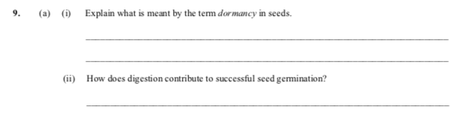

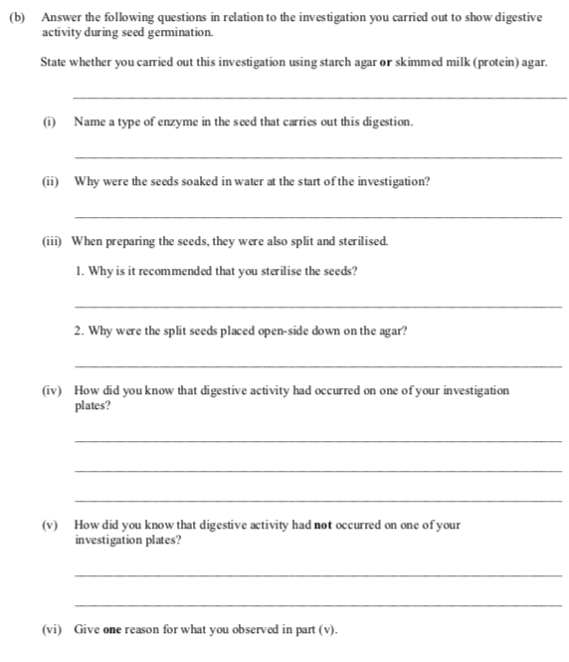

Section C

Sexual Reproduction

Higher Level

SEC Sample Paper HL
14. Answer any two of (a), (b), (c). (30,30)

(a) (i) From what does a seed develop?
(ii) Distinguish between endospermic and non-endospermic seeds.
(iii) Draw a diagram of a section through a named endospermic seed to show the structure of the embryo. Label three parts of the embryo and state a role for each part.
(iv) State one difference between the seeds of monocotyledons and dicotyledons other than the number of seed leaves.

2004 HL
14.
(a) The diagram shows a vertical section through a carpel.
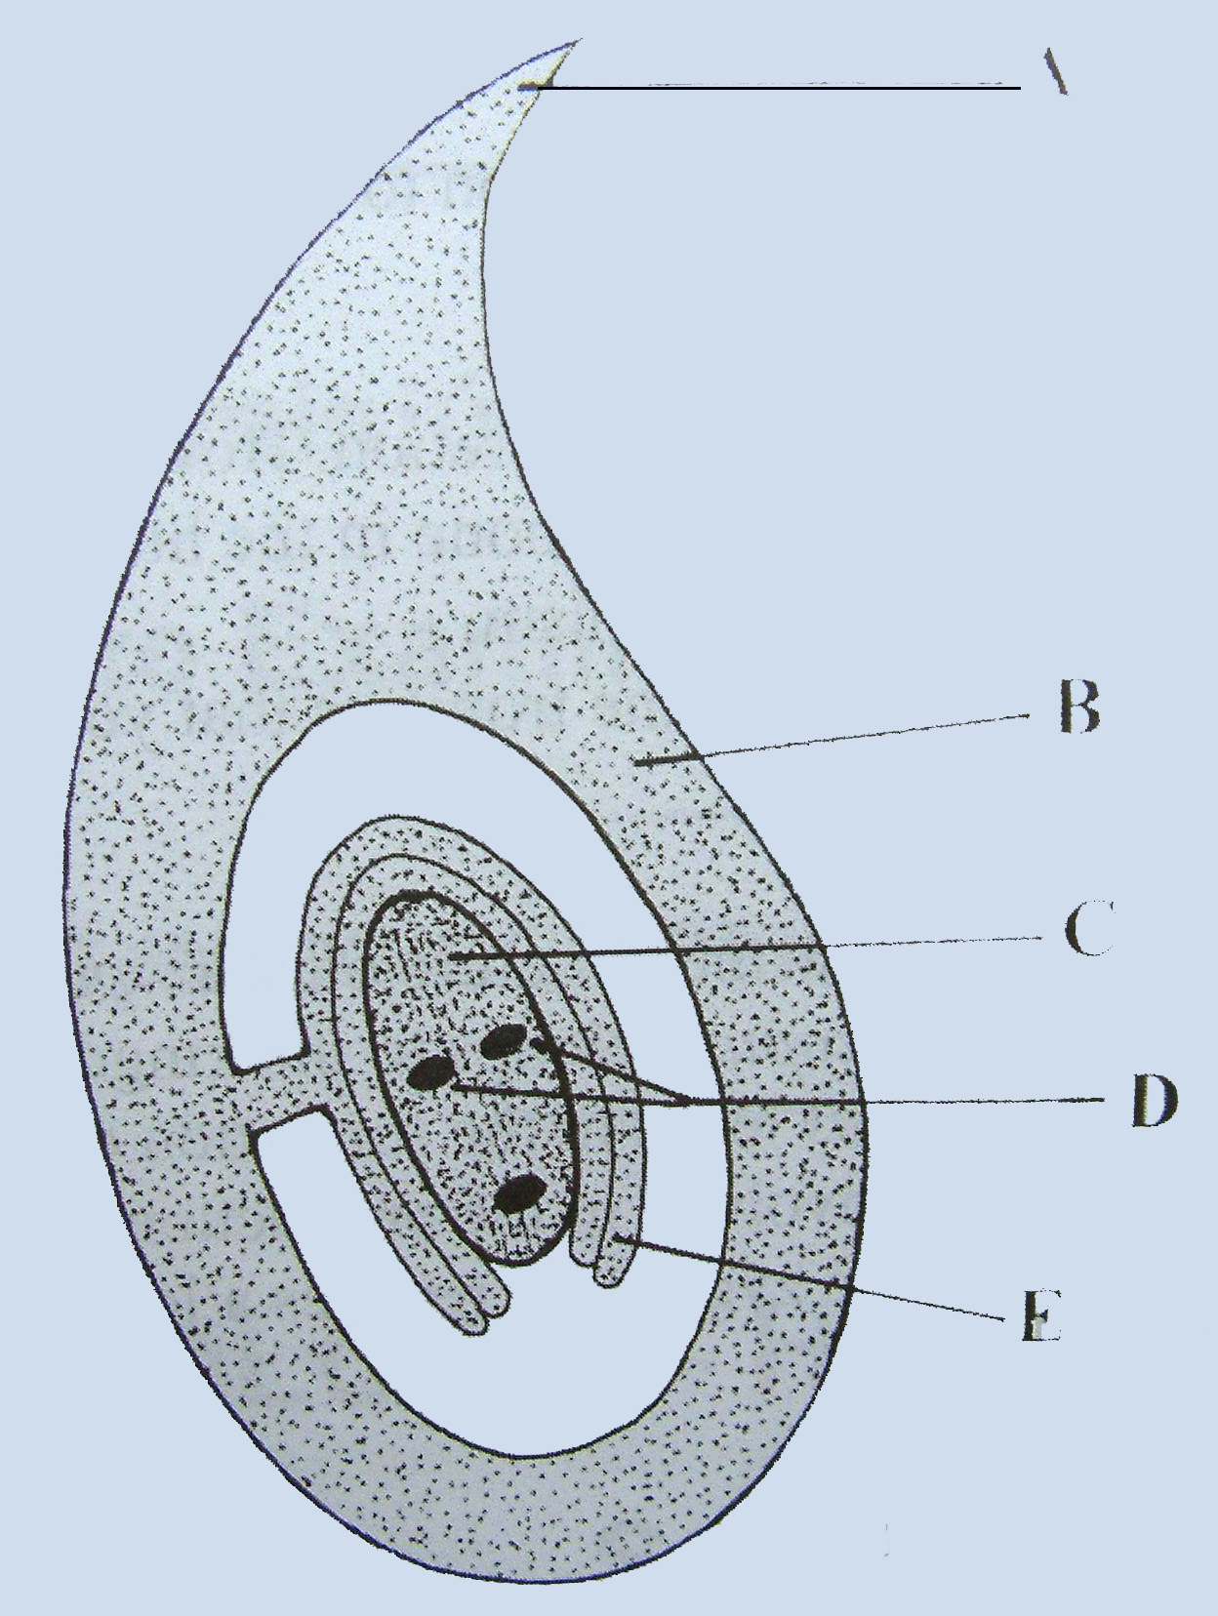
(i) Name A, B, C, D, E.
(ii) What happens to the two nuclei labelled D?
(iii) In the case of B and E state what may happen to each of them after fertilisation.
(iv) Copy the diagram into your answer book and add a pollen tube that has completed its growth. Label the nuclei in the pollen tube.

2006 HL
14. Answer any two of (a), (b) and (c). (30, 30)

(a) Answer the following in relation to sexual reproduction in flowering plants.
(i) State a role for each of the following: sepal, anther, stigma, ovary.
(ii) Distinguish between pollination and fertilization.
(iii) The two male gametes in the pollen tube are derived from the generative nucleus.
Do these gametes form as a result of mitosis or meiosis? Explain your answer.
(iv) Describe the fate of each of the male gametes.
(v) State one method that is used to produce seedless fruits.

2007 HL
14.
(a) (i) From what structure in the carpel does the seed develop?
(ii) State two locations in the seed where food may be stored.
(iii) The embryo plant within the seed has a number of parts. List two of these parts, apart from food stores, and give a role for each of them.
(iv) Following dispersal, the seed undergoes a period of dormancy. What is dormancy?
(v) Suggest two advantages of dormancy.

2009 HL
15. (a) (v) Seeds and fruits need to be dispersed.
Give:
1. Two methods of dispersal.
2. Two advantages of dispersal to the plant.

(c) Write notes on three of the following topics:
(iv) Adaptations of wind-pollinated flowers.

2010 HL
13. (a) Give a role for each of the following parts of a flower: sepals, anther, stigma. (9)

(b) (i) Describe the development of pollen grains from microspore mother cells.
(ii) What is meant by the term fertilisation?
(iii) Give a brief account of the process of fertilisation in flowering plants. (27)

(c) (i) What is meant by the dormancy of seeds?
(ii) Give one way in which the dormancy of seeds is of benefit to plants.
(iii) Suggest one way in which a knowledge of dormancy is useful to farmers and gardeners.
(iv) Water, oxygen and a suitable temperature are all required for the germination of seeds.
In the case of each of these factors describe its effect on the process of germination.
(v) Which part of the embryo in a germinating seed gives rise to each of the following parts of
the seedling?
1. The root
2. The shoot. (24)

2012 HL
14.
(a) (i) Give a brief account of the role of each of the following in flowering plant reproduction.
1. Petal.
2. Anther.
3. Stigma.
(ii) Name one structure through which the pollen tube grows in order to reach the embryo sac.
(iii) Within the pollen tube the generative nucleus divides to form two male gametes.
1. What type of division takes place?
2. With what does each male gamete fuse in the embryo sac?
3. Name the product of each fusion.
(iv) As the seed forms following fertilisation, a food store develops in one of two structures.
Name any one of these structures.
2014 HL Q14

2015 HL Q15
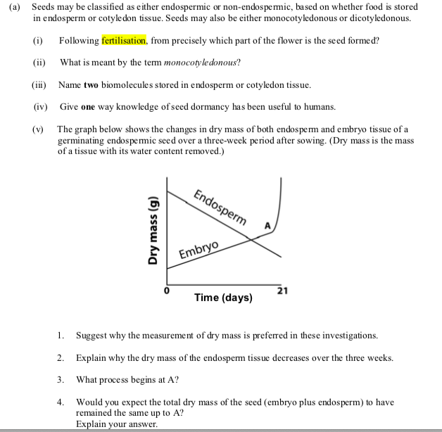
2018 HL Q14
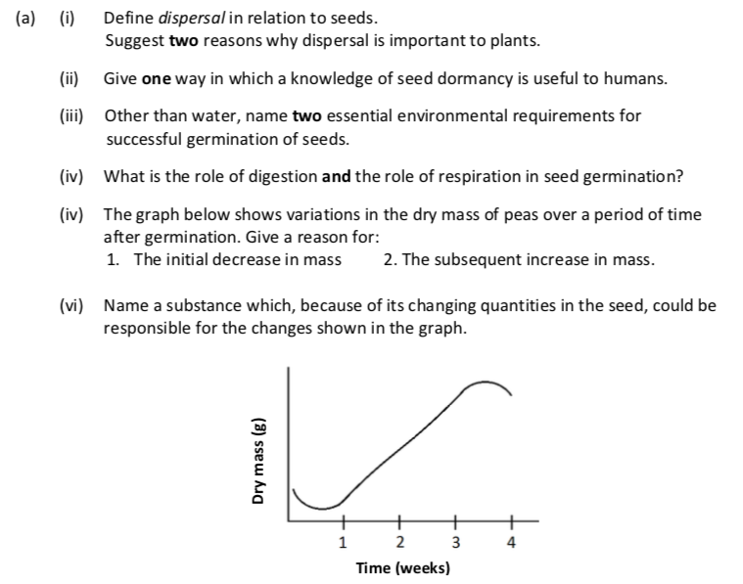

Asexual Reproduction

Higher Level

2006 HL
3. Distinguish between the members of each of the following pairs by making a brief comment on each.
(a) Tuber and bulb ………………………………………………………………………………
………………………………………………………………………………………………..
………………………………………………………………………………………………..
2013 HL
4. The diagram shows a strawberry plant from which a runner has given rise to a daughter plant.

(a) The runner is a modified stem. How could you tell this from
1. external observation? ___________________________________________________________
2. viewing a thin section of it under the microscope?_____________________________________
(b) What term is used for the type of asexual reproduction that produced the daughter plant?
_________________________________________________________________________
(c) Would you expect the daughter plant to be haploid or diploid? _____________________________
Explain your answer.______________________________________________________________
(d) What evidence is there in the diagram that sexual reproduction has also taken place?
_________________________________________________________________________
(e) Give one method, other than runners, and not involving seeds, that is used by horticulturists to
produce new plants.

Higher Level

SEC Sample Paper HL
14. Answer any two of (a), (b), (c). (30,30)

(b) (i) In relation to flowering plants explain what is meant by vegetative propagation.
(ii) Clones are genetically identical individuals. Are the products of vegetative propagation clones? Explain your answer.
(iii) Give two examples of natural vegetative propagation that involve different parts of a plant.
(iv) Describe two techniques of artificial vegetative propagation that are used for flowering plants. Suggest a benefit of artificial propagation.
2009 HL
15. (a) (i) What is meant by vegetative propagation?
(ii) Horticulturists use a number of methods to artificially propagate plants.
Suggest one advantage of artificial propagation.
(iii) Describe two methods used by horticulturists to artificially propagate plants.
(iv) Give two differences between vegetative propagation and propagation involving seeds.

2017 HL Q11

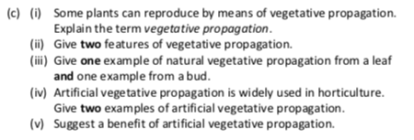

Section A

2005 HL Q3
3. |  |  | 5(1)+5(3)
 | (a) | False
 | (b) | False
 | (c) | True
 | (d) | True
 | (e) | True
 | (f) | True
 | (g) | False
 | (h) | True
 | (i) | True
 | (j) | True

2009 HL Q2
2. |  | 6(3) + 2
 | (a) | Radicle

2016 HL Q5

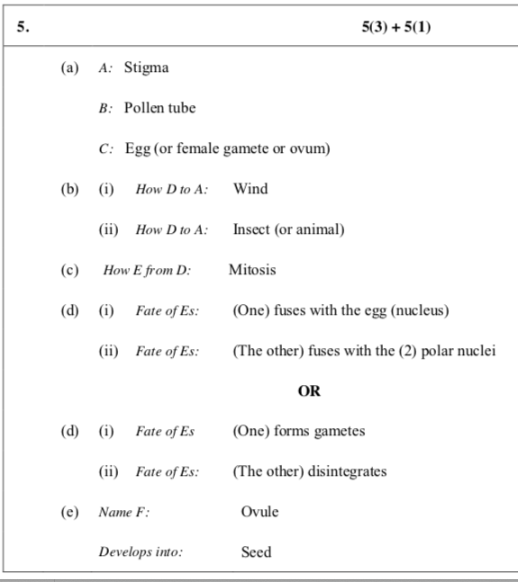

2017 HL Q6
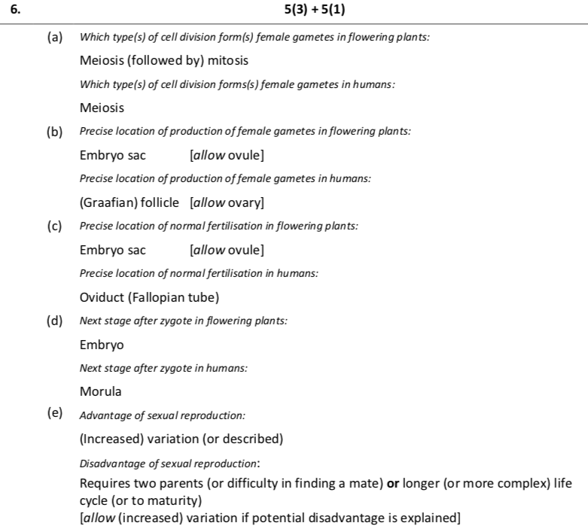

Section B

2006 HL Q7
7.
 |  | (ii) | 1. digestive or other enzyme activity  [accept culturing leaf yeasts or micro-organisms or bacteria]  2. supplies substrate or explained [accept medium] | 3  3

2009 HL Q8
8. | (a) | (i) | Growth of seed (or embryo part or of embryo) | 3
 |  | (ii) | To make (food) soluble or to make (food) transportable | 3
 | (b) | (i) | Petri dish containing a jelly (or solid medium) | 3
 |  | (ii) | Starch or milk | 3
 |  | (iii) | Soak (seeds) / split (seeds) / how sterilised correctly / position  (seeds) on agar / keep plate warm or stated temperature (max. 35°C) | 2(3)
 |  | (iv) | Boiled seeds | 3
 |  | (v) | Starch agar: Iodine (solution) or milk agar: biuret solution. | 3
 |  | (vi) | 1. No blue-black (under seeds) or no purple (under seeds)  2. Blue-black (under seeds) or purple (under seeds) | 3  3

2011 HL Q8
8b |  | (ii) | Keep temperature constant (or example) / to vary temperature (or example) / denaturing enzyme / heating Any 2 | 2(3)

2012 HL Q7
7 | b | (iii) | Milk or starch | 3
 |  | (iv) | Does not give a positive result where digestive activity occurred or described | 3
 |  | (v) | Anaerobic jar (or described) or boiled water + oil  or one with O₂ and one without O₂ (and compare) | 3

2013 HL Q9
9 | b | (iv) | 1. | Milk agar or starch agar | 3
 |  |  | 2. | Boiled seeds | 3
2014 Q7
2016 HL Q9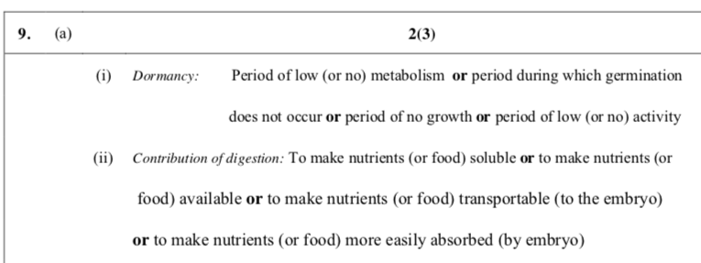
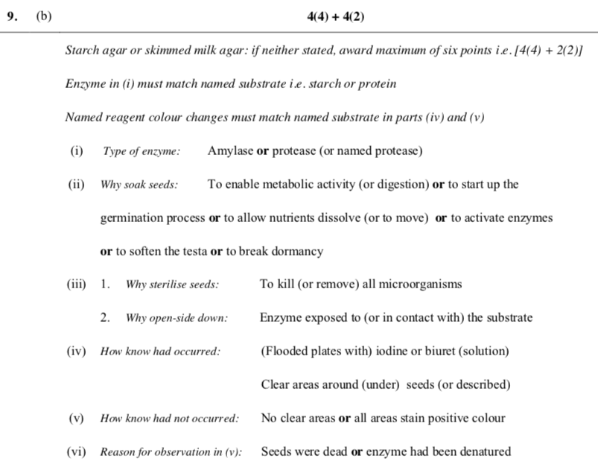

Section C

2004 HL Sample Q14 (a)
14. | (a) | (i) | Fertilised ovule | 3
 |  | (ii) | Endospermic retain endosperm at maturity. Non-endospermic have used it up by maturity | 3
 |  | (iii) | name of seed, e.g. maize  Diagram  Labels – 3 parts of embryo, plumule, radical, hypocotyls, epicotyls  Functions: embryo shoot/ embryo root/ attachment of radical and cotyledon/ attachment of plumule and cotyledon | 3  3,0  3(2)  3(2)
 |  | (iv) | Monocots store their food in the endosperm  Dicotyledons store their food in the cotyledons | 3  3

2004 HL Q14(a)
14. | Answer any two of (a), (b), (c).
 | (a) | (i) | A = stigma or style  B = ovary  C = embryo sac (allow nucellus)  D = polar nuclei  E = ovule (allow integuments) | 2  2  2  2  2
 |  | (ii) | What happens to D:  Fuse / form diploid (or primary endosperm) / (then fusion) to triploid or fertilisation / endosperm nucleus | 2(3)
 |  | (iii) | E becomes the seed or testa  B becomes the fruit | 2  2
 |  | (iv) | Diagram  2 named nuclei labels | 6, 3, 0  2(2)

2006 HL Q14(a)
14. | ANY TWO PARTS
 | (a) | (i) | sepal:  anther:  stigma:  ovary: | protection / photosynthesis / attracts insects  pollen - production or storage or release)  receives pollen  produces or contains ovule or embryo sac or female gametes/ becomes fruit / site of fertilisation | 3  3  3  3
 |  | (ii) | Pollination v fertilisation:  transfer (of pollen) versus fusion |  | 3
 |  | (iii) | mitosis  from haploid (generative nucleus) or chromosome  number retained or two (daughter cells) produced |  | 3  3
 |  | (iv) | one fuses with “egg” (nucleus)  other fuses with (primary) endosperm nucleus or polar nuclei |  | 3  3
 |  | (v) | growth regulator / selective propagation |  | 3

2007 HL Q14(a)
14. | Any two of (a), (b) or (c).
 | (a) | (i) | ovule* | 3
 |  | (ii) | cotyledon / endosperm | 2(3)
 |  | (iii) | radicle / plumule  develops root / develops shoot | 2(3)  2(3)
 |  | (iv) | when it does not germinate (despite favourable conditions) or period of low metabolism or explained | 3
 |  | (v) | germination at suitable time / time for embryo to develop / survival of  plant during unfavourable conditions / increased dispersal | 2(3)

2009 HL Q15(a)
15 | a | (v) | 1. Wind / animal / self (or mechanical) / water  2. Colonisation / reduces competition / elaboration of competition

2009 HL Q15(c)
15 | c | (iv) |  | Long stamens / long stigmas / feathery stigmas / large numbers of pollen grains / smooth pollen or light pollen / no showy colours or no scent or no nectar or small petals or no petals

2010 HL Q13
13. | (a) | Sepals:  Anthers:  Stigma: |  | protect flower (or bud) or photosynthesis or attract insects  produce pollen  traps (or catches) pollen [allow where pollen lands if qualified] |  | 3  3  3
 | (b) | (i) | Meiosis / 4 (or tetrad ) / haploid / micospores / (divides by) mitosis / tube and generative nucleus / pollen grain matures (or wall forms)  Any four |  |  | 4(3)
 |  | (ii) | Fusion of gametes or formation of zygote |  |  | 3
 |  | (iii) | Generative nucleus / mitosis / two male gametes (or nuclei) / one fuses with egg / to form zygote / other (male gamete or nucleus) fuses with (two) polar nuclei / to form endosperm  Any four |  |  | 4(3)
 | (c) | (i) | Period of reduced metabolism (or period of reduced activity) or period of no growth. |  |  | 3
 |  | (ii) | Survival or germination delayed until conditions suitable for growth or greater time for embryo development (or greater time for dispersal) or reduced competition |  |  | 3
 |  | (iii) | (Optimum) storage conditions or (optimum) sowing (or ploughing) time or (maximise) the growing season or seed treatment before sowing (or examples) |  |  | 3
 |  | (iv) | Water:  Suitable temp  Oxygen: |  | for enzyme action (or example of enzyme action) or as a solvent or transport of materials or bursting the testa [allow washing away inhibitors]  required for (optimum or increased) enzyme activity  needed for (aerobic) respiration | 3  3  3
 |  | (v) | - *Radicle  - *Plumule |  |  | 3  3

2012 HL Q14
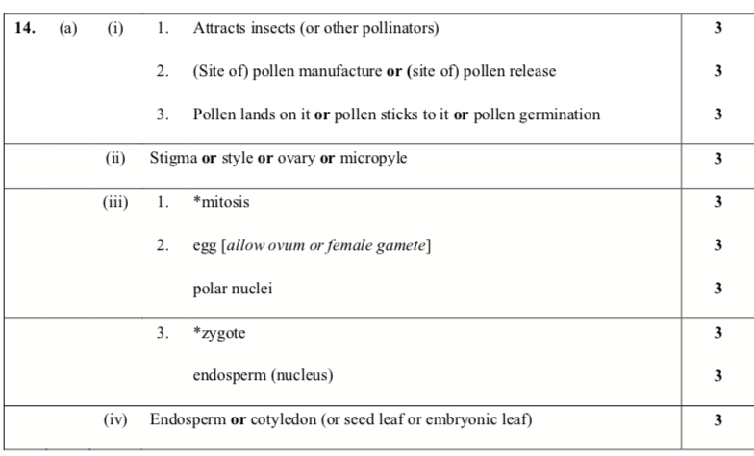
2014 HL Q14
2015 HL Q15
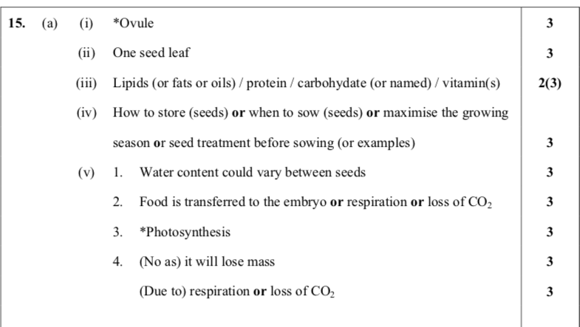
2016 HL Q15
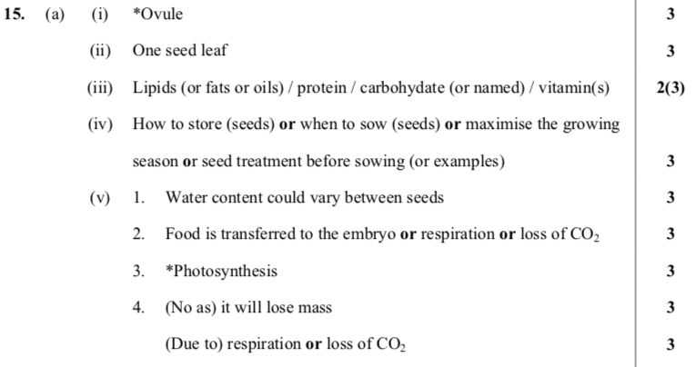

2017 HL Q11

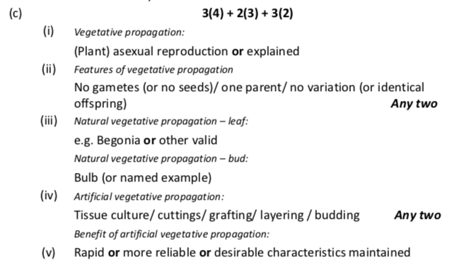

2018 HL Q14

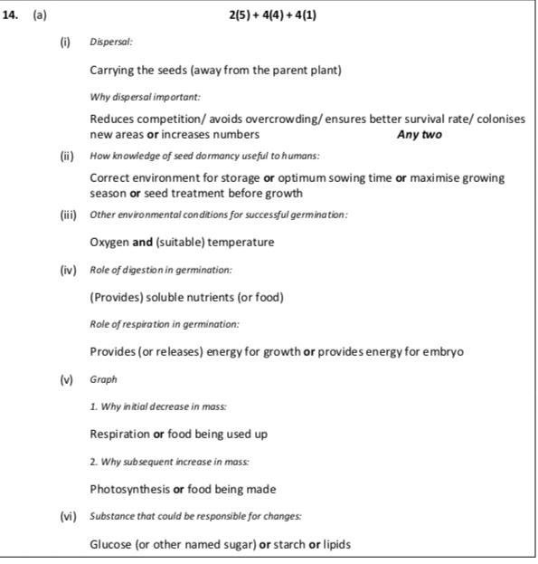
Asexual Reproduction
Section A

2006 HL Q3
3 |  |  | 5(2+2)
 | (a) | tuber: stem or root [2 for all who attempt question]  bulb: leaf or bud

2013 HL Q4
4. | 6(3) + (2)
 | (a) | 1. | Bud(s) or node(s) or leaf
 |  | 2. | Vascular bundles [plural only]
 | (b) | Vegetative propagation
 | (c) | Diploid
 |  | Product of mitosis or genetically identical (to parent) or clone
 | (d) | Fruit or (straw)berries or seeds
 | (e) | Cuttings or layering or grafting or micro-propagation or tissue culture

Section C

2004 HL Sample Q14 (b)
14. | (b) | (i) | Asexual reproduction/ production of new plant from stem or root or leaf | 6
 |  | (ii) | Yes  Clones result from mitosis/ vegetative propagation is by mitosis | 3  2(3)
 |  | (iii) | Strawberry Runners- horizontal stems/ Potatoes stem tubers/ Dahlia root tubers/ Bryophyllum – leaf plantlets, Onion bulbs- buds Any two | 2(3)
 |  | (iv) | Cuttings ( or described)/ layering (or described)/ grafting (or described)/ Micro propagation ( or described). Any two  Benefit:Quick/ preserves desirable features/ cheap/ more reliable | 2(3)  3

2009 HL Q15(a)
15. | Any two of (a), (b), (c) |  |  | (30, 30)
15. | (a) | (i) | Production of new plant from root or from stem or from leaf or  plant asexual reproduction (or described)
 |  | (ii) | Fast or preserves desirable features or cheap or more reliable
 |  | (iii) | Cuttings (or described) / layering (or described) / grafting (or  described) / micro propagation (or described)
 |  | (iv) | No gametes (or one parent) / identical plants or example / rapid  production / no outside agent
 |  | (v) | 1. Wind / animal / self (or mechanical) / water  2. Colonisation / reduces competition / elaboration of competition

2017 HL Q11
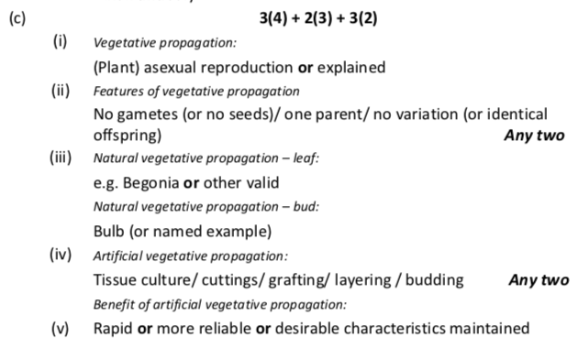

Ordinary Level
Section A
2005 OL
3. The diagram shows the external structure of a stamen.
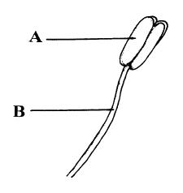
(a) Name A and B
A …………………………........… B ………………………………..
(b) Where is pollen produced, in A or in B? ………………………………..
(c) To which part of a flower is pollen carried? ………….……………………………
(d) What is meant by cross-pollination? ………………………………………..
………………………………………………………………………………………………………
(e) Name two methods of cross-pollination.
1. …………………………………………………………………………………………..…..

2. ……………………………………………………………………………………………...

Ordinary Level
Section B

SEC Sample Paper OL
9. (a) What is meant by the germination of a seed? ………………………….……………………………
…………..……………………………………………………………………………………………
State three environmental factors that are necessary for germination
1. ……………………………………………………………………………………
2. ………………………………………………………………………………………
3. ………………………………………………………………………………………
(b) Answer the following in relation to an experiment that you carried out to investigate the effect of these factors on germination.
What seeds did you use? ………………………………………………………………………………
Draw a labelled diagram of the apparatus that you used.

Describe how you carried out the experiment
………………………………………………………………………………………………………………………………………………………………………………………………………………………………………………………………………………………………………………………………………………………………………………………………………………………………………………………………………………………………………………………………………………………………………………………………………………………………………………………………………………………………………………………………………………………………………………………………………………………………………………………………………………………………………………………………………………………………………………………………………………………………………………………………………………………………………………………………………………

State the results of your experiment …………………………………………………………………………………..
…………………………………………………………………………………………………………………………………………………………………………………………………………………………………………………………………………………………………………………………………………………………………………………………………………………………………………………………………………………………………………

2005 OL
9. (a) (i) What is meant by the germination of a seed? ……….………………………………….………
………………………………………………………….……….………………………………
(ii) State one reason why water is needed for germination. ……………………………….………
………………………………………………………………………………………………….
(b) Answer the following questions in relation to an experiment that you carried out to investigate the effects of water, oxygen and temperature on germination.
(i) Draw a labelled diagram of the apparatus that you used.

(ii) Describe how you carried out the experiment. …………………………………………………
………………………………………..…………………………………………………………………
…………………………………..………………………………………………………………………
……………………………..……………………………………………………………………………
………………………..…………………………………………………………………………………
…………………..………………………………………………………………………………………
…………..………………………………………………………………………………………………
……..…………………………………………………………………………………………………….
…………………………………………………………………………………………………….………
…………………………………………………………………………………………….………………
…………………………………………………………………………………….………………………
………………………………………..………………………………………………………………….
(iii) Describe the results of this experiment, including the result of the control. …………………….
……………………………………………………………………………………………………………
…..……………………………………………………………………………………………………..…
…………………………………………………………………………………………………..……..…
……………………………………………………………………………………………………………
………………………..……………..……………………………………………………………………
……………………………………………………………………………………………………………

2006 OL
9. (a) (i) Give one location in a seed in which food is stored. ……………………………..……………
…………………………………………………………………………………………………..
(ii) Name a carbohydrate that you would expect to be present in this food store. …………………
…………………………………..………………………………………………………………

(b) In your practical work you investigated digestive activity during germination.
(i) What type of agar did you use in this investigation? …………………………………………..
…………………………………………….…………………………………………….........................
….................................……………………………………………….............…………………………
(ii) Describe how you carried out the investigation. Refer to a control in your answer.
…………………………............………………………………………………………………….…...…
……............………………………………………………………………………………….…….………
……............………………………………………………………………………….……….……………
……............………………………………………………………………….…………..…………………
……............………………………………………………………….……………..………………………
……............………………………………………………….…………............…………………………
……………………………………………………….…………............…..……………………………
………………………………………………….…………………............………………………………
………………………………………….………………………….............………………………………
………………………………….………………………............…………………………………………
………………………….…………………………………............………………………………………
………………….………………………………............….………………………………………………
………….……………………………………….........................................................................................
......................................................................................................................................................................
......................................................................................................................................................................
........………………………………………………………………………………………………………..
(iii) Describe the results of your investigation.
............…………………………………………………………………………………………….............…………………………………………………………………………………………….............…………………………………………………………………………………………….............…………………………………………………………………………………………….............…………………………………………………………………………………………….............…………………………………………………………………………………………….............………………………………………………………………………………………………………………………………………………………………………………………………………………………………………..……………………………………………………………………………………………………………………………………………………………………………………..
Answer

2008 OL
9. (a) (i) What is meant by the germination of seeds? ___________________________________
________________________________________________________________________
(ii) Seeds may remain inactive for a period before germination. What term is used to describe
this period of inactivity?____________________________________________________
(b) Answer the following questions about an investigation that you carried out on the effect of water, oxygen and temperature on germination.
(i) What seeds did you use? ___________________________________________________
(ii) Explain how you set up a control for the investigation.
________________________________________________________________________
________________________________________________________________________
________________________________________________________________________
________________________________________________________________________
________________________________________________________________________
________________________________________________________________________
(iii) How did you deprive some of the seeds of oxygen?
________________________________________________________________________
________________________________________________________________________
________________________________________________________________________
________________________________________________________________________
(iv) How did you ensure that some of the seeds were deprived of a suitable temperature for
germination? ____________________________________________________________
________________________________________________________________________
________________________________________________________________________
(v) State the results of the investigation, including those of the control.
________________________________________________________________________
________________________________________________________________________
________________________________________________________________________
________________________________________________________________________
________________________________________________________________________
________________________________________________________________________
________________________________________________________________________

2009 OL
9. (a) (i) What is meant by the term digestion?
_______________________________________________________________________
(ii) Why does digestion occur in seeds during germination?
_______________________________________________________________________
(b) Answer the following questions in relation to practical work you carried out to investigate
digestive activity in germinating seeds.
(i) Name a plant that provides suitable seeds for this investigation.
_______________________________________________________________________
(ii) The seeds were divided into two batches. One batch was used untreated.
How did you treat the other batch of seeds before using them in the investigation?
_______________________________________________________________________
(iii) Explain why you treated the second batch of seeds in the way described in (ii).
_______________________________________________________________________
_______________________________________________________________________
(iv) Describe how you carried out the investigation. In your description outline how you
demonstrated that digestion had occurred.
_______________________________________________________________________
_______________________________________________________________________
_______________________________________________________________________
_______________________________________________________________________
_______________________________________________________________________
_______________________________________________________________________
_______________________________________________________________________
(v) Give the results of your investigation.
_______________________________________________________________________
_______________________________________________________________________
_______________________________________________________________________
_______________________________________________________________________

2011 OL
8. (b) For what purpose did you use each of the following in the course of your practical
activities?

(ii) Anaerobic jar.
Purpose. _________________________________________________________________

Section C
SEC Sample Paper OL
12.
(iii) From what part of the embryo plant within the seed does the root develop?

(c) Flowering plants are classified as monocotyledons or dicotyledons.
(i) What is a cotyledon?
(ii) Name a monocotyledon.
(iii) Name a dicotyledon.
(iv) Copy the following table into your answer book and distinguish between monocotyledons and dicotyledons by completing the empty boxes. (27)

 | Monocotyledon | Dicotyledon
Distribution of veins leaf
Leaf shape
Distribution of vascular tissue in stem
SEC Sample Paper OL
15. (c) The diagram shows a section through a flower.

(i) Name the parts A, B, C, D.
(ii) State a function of the part labelled C.
(iii) In which part of the flower is pollen produced?
(iv) In which part of a flower does a seed form?
(v) Name a part of a flower that may develop into a fruit.
(vi) Some flowers have nectaries. How are these flowers pollinated? Explain your answer. (30)
2004 OL
14. (a) (i) State a function of each of the following parts of a flower:
1. petal 2. sepal 3. anther.
(ii) Explain what is meant by pollination. What is the difference between self-pollination and cross-pollination?
(iii) Name two ways in which cross-pollination happens.
(iv) Suggest why cross-pollination is preferable to self-pollination.

(b) (i) Name a part of a flower from which a fruit develops.
(ii) In each of the following cases give one example of a plant that uses the stated method of seed dispersal:
1. wind
2. animal.
(iii) Why is it important for plants to disperse their seeds?
(iv) What is meant by the dormancy of seeds?
(v) Suggest an advantage of dormancy of seeds to a plant.

(c) (i) What is meant by germination?
(ii) List three factors that are essential for germination.
(iii) In the case of one of the factors that you have named in (ii), explain how it affects germination.
(iv) Describe an experiment to demonstrate that the factors you have named in (ii) are essential for germination. Include a diagram of the apparatus in your answer.

2006 OL
14. (c) The diagram shows a vertical section through a flower.

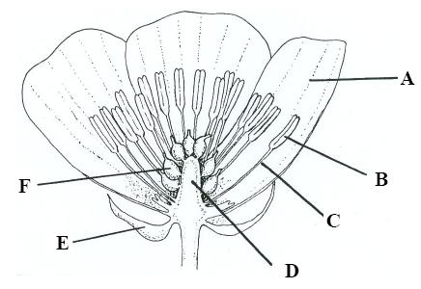

(i) Identify parts A, B, C, D, E and F.
(ii) What is the function of A? Give two ways in which it may be adapted for this function.
(iii) In which part is pollen produced?
(iv) Give two ways in which pollen may be transported to another flower.
(v) What forms in F after pollination and fertilization?

2007 OL
14. (c) (i) In the table below, which letter gives the correct order of events in the life cycle of a
flowering plant – A, B, C, D or E?

A | germination seed and fruit formation growth pollination fertilisation dispersal
B | germination fertilisation seed and fruit formation growth dispersal pollination
C | germination fertilisation growth seed and fruit formation pollination dispersal
D | germination growth pollination fertilisation seed and fruit formation dispersal
E | germination seed and fruit formation growth fertilisation dispersal pollination

(ii) Distinguish clearly between pollination and fertilisation.
(iii) State a location in the seed where food is stored.
(iv) What is germination?
(v) State three factors necessary for the germination of a seed.

2008 OL
14. (a) The diagram shows the structure of a flower.

(i) Name the parts labelled A, B, C, D.
(ii) In which labelled part is pollen produced?
(iii) What is meant by pollination?
(iv) From the list below, choose three characteristics in each case of;
1. an insect-pollinated flower,
2. a wind-pollinated flower.
brightly coloured petals, feathery stigmas, anthers within petals, anthers outside petals, nectaries, petals reduced or absent.
(v) What process follows pollination in the life cycle of a flowering plant?

2009 OL
14. (c) (i) Name a part of the flower from which fruit forms.
(ii) Give three examples of the ways in which fruits are involved in seed dispersal.
(iii) Suggest why it is necessary for a plant to disperse its seeds.
(iv) Following dispersal most seeds enter a period of dormancy. What is dormancy?
(v) Give an advantage of dormancy.
(vi) Name the stage in the plant’s life cycle that follows dormancy.
(vii) State one way in which it is possible to produce seedless fruits in horticulture.

2010 OL
14.
(c) (i) What is meant by fertilisation?
(ii) Name the part of the flower in each case
1. Where fertilisation occurs
2. That becomes the fruit.
(iii) Each seed is made up of an embryo, a food store and a seed coat (testa). One function of fruit is to aid dispersal.
Explain each of the underlined terms.
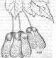
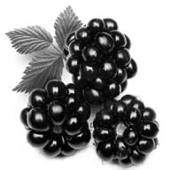

Blackberries Sycamore fruit
(iv) By which method are the seeds of each of the fruits shown above dispersed?
(v) What term is given to the growth of an embryo into a plant?
(vi) In order for this growth to be successful, certain environmental conditions must be
present. Name any two of these conditions.

2011 OL
15.
(a) (i) Draw a large labelled diagram to show the internal structure of a flower.
(ii) Give two ways by which pollen is transferred from one flower to another.
(iii) After fertilisation, what part of the flower becomes the fruit?
(iv) Many seedless fruits, e.g. grapes, are available in shops today.
State one way of forming seedless fruits.
(v) Sometimes artificial methods are used to propagate (reproduce) plants.
Name any two methods of artificially propagating plants.

2011 OL
15.

(iii) From what part of a seed does the root develop?

2012 OL
12. (a) (i) Name the two main types of reproduction.
(ii) Explain the term fertilisation. (9)

(b) The flower is the organ of reproduction in many plants.
(i) What part of the flower produces pollen?
(ii) After fertilisation, what part of the flower becomes the fruit?
(iii) Give two methods of seed dispersal in plants.
(iv) Why is it necessary for plants to disperse their seeds?
(v) What is the advantage of dormancy to seeds?
(vi) Give three conditions necessary for seeds to germinate. (27)

2013 OL
15.
(a) The diagram shows the structure of a flower.

(i) Name the parts labelled A, B, C and D.
(ii) What is meant by the term pollination?
(iii) Give two methods of pollination in plants.
(iv) What is the next step after pollination in the lifecycle of the plant?
(v) Suggest a substance that flowers produce that may cause hay fever in some people.

Asexual Reproduction
2013 OL
15.
(b) (i) What is meant by the term vegetative propagation?
(ii) Give one example of vegetative propagation in plants and state whether it involve a stem, a
root, a leaf or a bud.
(iii) State two ways that vegetative propagation differs from reproduction by seed.
(iv) Artificial propagation is widely used in horticulture. Give two example of artificial propagation
carried out by gardeners or horticulturists.
(v) Give one advantage and one disadvantage of artificial propagation.

2005 OL
15. (b) (i) What is vegetative propagation?
(ii) Give one example of vegetative propagation and state whether it involves a stem, a root, a leaf or a bud.
(iii) How does vegetative propagation differ from reproduction by seed?
(iv) Artificial propagation is widely used in horticulture. Give two examples of artificial propagation.
(v) Suggest one advantage and one disadvantage of artificial propagation.

Ordinary Level

2005 OL Q3
3. | 7 answers |  | 2(5)+5(2)
 | (a) | A = Anther B = Filament
 | (b) | A
 | (c) | carpel / stigma / female / ovary / style / ovule
 | (d) | Transfer of pollen from one flower / plant to another
 | (e) | Wind / animal / named animal any two

2004 OL Sample Q9
9. | (a) |  | The growth of a seed/ sprouting/ re growth of the embryo plant | 3
 |  |  | Moisture (water) / warmth (correct temperature) / oxygen | 3(1)
 | (b) |  | Seed type: mustard/ cress/ radish/ peas | 3
 |  |  | Diagram: 4 dishes/ tubes. A- minus water/ B minus oxygen/ C with every thing/ D – minus correct temperature.  Labels to match diagrams. ( title may be considered a label) | 6,3,0  3
 |  |  | Set up apparatus as in sketch / placed A, B and C in incubator at 20 °C / place D in fridge / for 2-3 days | 3(3)
 |  |  | A, B, D – no germination  C – germination | 3  3

2005 OL Q9
9. | (a) | (i) | growth/sprouting | 3
 |  | (ii) | chemical (enzyme) reactions/ dissolve stored food/swell testa / a condition of germination | 3
 | (b) | (i) | Diagram (minimum = test tube, seeds, variable)  Control  Label – (title may be considered a label) | 6, 3, 0  3  3
 |  | (ii) | presence of variable / absence of variable | 2(3)
 |  | (iii) | results of experiment  results of controls | 3  3

2006 OL Q9
9. | (a) |  |  | 5+1
 |  | (i) | Endosperm or cotyledon or (seed) leaf or nucellus or around the embryo
 |  | (ii) | Starch (allow sugar or named sugar)
 | (b) |  |  | 4(5)+4(1)
 |  | (i) | Starch or skimmed milk / malt / nutrient | any five
 |  | (ii) | (Named) seeds / soak seeds / some seeds killed / split seeds / live seeds in one plate/ dead seeds in other plate/ identical conditions/ number of days/remove seeds/ add iodine solution / observe /disinfect seeds.
 |  | (iii) | Agar stays red-brown where live seeds were placed/ agar turns blue-black in other plate  N.B. If skimmed milk agar is used then protein digestion is being tested so the Biuret test will be used and the result will be blue for live seeds and purple for dead seeds

2008 OL Q9
9. | (a) |  |  | 5, 1
 |  | (i) | Growth
 |  | (ii) | Dormancy
 | (b) |  |  | 4(5)+2(2)
 |  | (i) | type of seed (monocot or dicot or gymnosperm or angiosperm))/ name of seed
 |  | (ii) | Provide suitable condition(s)
 |  | (iii) | anaerobic jar or other
 |  | (iv) | put in fridge or cold environment (accept freezer or oven)
 |  | (v) | i. All conditions – growth (mandatory point)  one of the following  i. no oxygen – no germination  ii. or low temperature – no germination  iii. or no moisture – no germination | Two pts –  Mandatory + one other

2009 OL Q9
9. |  |  |  | 5 + 1
 | (a) | (i) | Breaking down food
 |  | (ii) | Soluble / for transport / allow ‘glucose for respiration’
 | (b) | (i) | Any suitable plant | 2(9) + 6(1)
 |  | (ii) | Boiling
 |  | (iii) | Destroys enzymes / allow ‘to kill seeds or cells’/ allow ‘control’
 |  | (iv) | e.g. agar plates / seeds on / test type
 |  | (v) | Experiment result  Control result

2011 OL Q8
8 | b | (ii) | To see if O₂ is necessary for germination / to limit or reduce O₂

Section C

2004 OL Sample Q12
12 | b | (iii) | Radicle | 3
 | (c) | (i) | A seed leaf / embryonic leaf | 3
 |  | (ii) | Daffodil / onion / any correct | 3
 |  | (iii) | Daisy / dandelion / buttercup / any correct | 3
 |  | (iv) |  | 6(3)
   | Monocotyledon | Dicotyledon
  Distribution of veins in leaf | parallel | Netted / reticulate
  Leaf shape | Strap | broad
  Distribution of vascular bundles in stem | No definite pattern | Definite pattern

2004 OL Sample Q15 (c)
15. | (c) | (i) | A – petal,  B – anther,  C – sepal,  D – carpel | 4(3)
 |  | (ii) | C – protection / photosynthesis Any one | 3
 |  | (iii) | The anther / stamen | 3
 |  | (iv) | The carpel / ovary / ovule | 3
 |  | (v) | The ovary / ovary wall | 3

2004 OL Q14(a)
14. | Answer any two of (a), (b), (c).
 | (a) | (i) | 1. attraction of insects or feature of or platform for insects to land on  any one  2. protection (of flower)(bud) or photosynthesis any one  3. (production, storage, use of) pollen | 3  3  3
 |  | (ii) | transfer of pollen / to carpel (stigma) or to female  self pollination – occurs on same plant (or flower)  cross pollination – occurs between plants | 2(3)  3  3
 |  | (iii) | wind/animal any two | 2(3)
 |  | (iv) | cross pollination increases variation or reduces chance of genetic problems | 3

2004 OL Q14(b)
 | (b) | (i) | carpel/ ovary/ style / receptacle any one | 3
 |  | (ii) | wind dispersal e.g. dandelion/ sycamore any one  animal dispersal e.g. blackberry/ burdock any one | 3  3
 |  | (iii) | colonise new areas/ reduce competition/survival of species any two | 6+3
 |  | (iv) | period of very low metabolism or period before germination or period during which germination will not occur any one | 6
 |  | (v) | to prevent germination in unfavourable conditions or has longer period available for dispersal or (evolution has guaranteed) optimal germination conditions. any one | 6

2004 OL Q14(c)
 | (c) | (i) | (resumption of) growth of seed or explained any one | 3
 |  | (ii) | suitable temperature/ oxygen/ water | 3(3)
 |  | (iii) | oxygen – needed to respire or needed for energy  water – needed as medium for reactions or needed as solvent for food  store or needed for formation of new tissue or needed for splitting testa  or needed for absorbing minerals.  suitable temperature – optimal temp. for enzymes any one | 3
 |  | (iv) | diagram (showing vessel, seeds & cotton wool (at least one of which must be labelled)  (Any one missing only allow 3 marks – more missing = 0)  seeds/ experiment or one factor missing / explain how one factor was removed / control or all three factors present / identical conditions / leave for period/ observe or state result any three | 6, 3, 0  3(3)

2005 OL Q15(b)
 | (b) | (i) | asexual reproduction (in plants) / cloning |  | 6
 |  | (ii) | “Seed” potatoes  Runners of strawberries etc. Tuber of Dahlia  Bulb of onion  New plants from leaf  Artificial examples  Cuttings/grafts/layers | - stem  . - stem  - root  - stem/leaf/bud  - leaf  - stem, bud, stem  any one example | 3+3
 |  | (iii) | One parent / less variation in offspring /no pollination /no sexual reproduction |  | 6
 |  | (iv) | cutting /grafting /layering /micropropagation any two |  | 2(3)
 |  | (v) | Advantage – simple/fast/ same as parent / avoids competition  Disadvantage – lack of variation / diseases inherited |  | 3  3

2006 OL Q14(c)
14. | (c) |  |  |  | [this last mark of 2 is tied to part (v) below] | 4(5) + 8(1) + 2
 |  | (i) |  |  | A = petal  B = anther  C = filament  D = receptacle  E = sepal  F = carpel or ovary or pistil
 |  | (ii) |  |  | To attract insects or pollination  Colour/ scent/ size/ shape any two
 |  | (iii) |  |  | Anther or stamen
 |  | (iv) |  |  | Wind /insect or animal / artificial any two
 |  | (v) |  |  | Seed or zygote or embryo or food reserve

2007 OL Q14(c)
 | (c) |  |  |  |  |  | 3(6)+6(2)
 |  |  | (i) | D
 |  |  | (ii) | pollination – transfer of pollen  fertilisation – fusion of gametes or of sex cells  [allow fusion of egg and sperm or of “pollen” and egg cell]
 |  |  | (iii) | endosperm or cotyledon or seed leaf
 |  |  | (iv) | growth / of embryo plant or of seed
 |  |  | (v) | oxygen/ water/ suitable temperature or warmth [allow light]

2008 OL Q14(a)
14. |  | Answer any two of (a), (b), (c). |  |  |  |  |  | (30, 30, )
 |  | (a) |  |  |  |  |  | 6(1) + 8(3)
 |  |  | (i) |  | A = anther/stamen/ androecium B = carpel / ovary / ovule / gynoecium C = sepal / calyx D = receptacle |  |  | Four pts
 |  |  | (ii) |  | A (watch for follow-on)
 |  |  | (iii) |  | Transfer/ of pollen/ (allow anther to stigma) |  |  | Two pts
 |  |  | (iv) |  | 1. brightly coloured petals / anthers within petals, nectaries,  2. feathery stigmas, anthers outside petals, petals absent or  reduced. |  |  | Three pts  Three pts
 |  |  | (v) |  | fertilisation

2009 OL Q14(c)
 | (c) |  |  |  |  |  |  |  | 6 +11 + 6(2)  +1
 |  |  |  | (i) |  | Ovary / Carpel / Receptacle | 6 (This ‘6’ is affixed to Part (i) exclusively)
 |  |  |  | (ii) |  | Animal dispersal / Winged / Wind /Self dispersal / Water Dispersal / Human dispersal / or Examples Any three
 |  |  |  | (iii) |  | To avoid competition / colonisation
 |  |  |  | (iv) |  | Period of no growth
 |  |  |  | (v) |  | e.g. Survival / Avoid harsh winter weather
 |  |  |  | (vi) |  | Germination / allow Growth
 |  |  |  | (vii) |  | e.g. (Growth) regulators

2010 OL Q14(c)
 | (c) | (i) | Fusion of gametes or formation of zygote | 2(6) + 2(3) + 6(2)
 |  | (ii) | 1. Embryo sac or ovule or ovary or carpel  2. Carpel or ovary or receptacle
 |  | (iii) | Embryo: (part of seed that) becomes the new plant  Dispersal: spreading of seeds
 |  | (iv) | Blackberries: Animals  Sycamore fruit: Wind
 |  | (v) | Germination
 |  | (vi) | Suitable temperature/moisture/O2 [Allow ‘pH’ and allow ‘light’ if light is linked to ‘some seeds’ or specifically named seed]  (Two points)

2011 OL Q15(a)
15. |  |  |  | Any two of (a), (b), (c) | (30, 30)
15. | (a) | (i) | Diagram must show at least three of the following:  Sepals, Petals, Stamens, Carpels = 6 marks  (Any two missing then only 3 marks and any three missing then zero marks) |  |  | 6,3,0 + 3(2)  (3 Labels)
 |  | (ii) | Wind / insects / birds |  |  |  | 6(3)  2(Pts)
 |  | (iii) | Ovary (allow ‘carpel’)
 |  | (iv) | Genetic engineering / growth regulators / hormones / selective breeding
 |  | (v) | Grafting/cutting/layering... |  |  |  | 2(Pts)

2011 OL Q15(b)
15 | b | (iii) | Radicles (allow embryo)

